STRATEGIC REVIEW ON THE ACHIEVEMENT OF SUSTAINABLE DEVELOPMENT GOAL 2 (FOOD SECURITY, NUTRITION AND SUSTAINABLE AGRICULTURE) IN JORDAN
Background
The Strategic Reviewis proposed as an analytical and consultative process led by His Royal Highness Prince El Hassan Bin Talal with support from the Higher Council for Science and Technology (HCST) and the National Centre for Research and Development (NCRD).
Based on the National Voluntary Review of Jordan on the Sustainable Development Agenda 2030, the Review will delve into priority actions to achieve Sustainable Development Goal 2 (SDG 2).The Review will contribute to national development plans (Jordan’s 2025 vision) and humanitarian plans (refugee response plans). It will inform the efforts of the Government of Jordan, which has the primary responsibility for the achievement of the SDGs, by laying out concrete actions for the Government and partners to accelerate progress toward SDG 2.
Focus and Objectives
In Jordan, SDG 2is key to the achievement of other SDGs –namely SDG 1 on poverty reduction; SDG 6 on clean water and sanitation; SDG 7 on affordable and clean energy; SDG 11 on sustainable cities and communities; and SDG 16 on peace, justice and strong institutions similarly, progress on these SDGs contributes significantly to the achievement of SDG 2. The Strategic Review would provide an opportunity therefore to focus on the linkages between SDG 2 and the other SDGs, taking into consideration regional dynamics, peace and security.
Recognizing the centrality of partnerships for the SDGs, the Review will also explore opportunities provided by SDG 17 on partnerships, namely the role of the private sector, public private partnerships, and the diversification of financing for development.
Thespecific objectives of the Strategic Review are:
  - To review the food security and nutrition situation, including sustainable agriculture, for all people living in Jordan, including refugees, and explore the interlinkages between SDG 2 and regional dynamics, peace processes, the refugee crisis, water and energy issues, poverty reduction, urbanization and human dignity;
  - To determine the progress that policies and programmes aimed at improving food security and nutrition have made for women, men, girls and boys;
  - To identify gaps in the response, with focus on programmatic gaps, institutional capacity and financial resources;
  - To discuss and prioritize actions that will be required to meet response gaps and accelerate progress toward zero hunger, and provide an overview of how these actions may be implemented; and
  - To identify partnerships and opportunities for the contribution of all stakeholders, including the private sector and UN agencies.
Principles
The review would be undertaken, taking the following principles into account:
- The process would be inclusive, consultative and should reach out to all relevant stakeholders, including government institutions, national private sector, academia, non-governmental organizations, international organizations including international financial institutions and donors;
- The analysis would be comprehensive, holistic, gender- and age-sensitive and focused on all pillars of SDG2 targets for ending hunger;
- The analysis would be action-oriented and serves to draw clear evidence in support of priority actions;
- The review would draw connections to the other SDGs as appropriate for the national context; and
- The review would look at immediate humanitarian needs as well as longer-term food security, nutrition and sustainable agriculture.

Strategic Review Structure
The Review is managed as per the following structure.
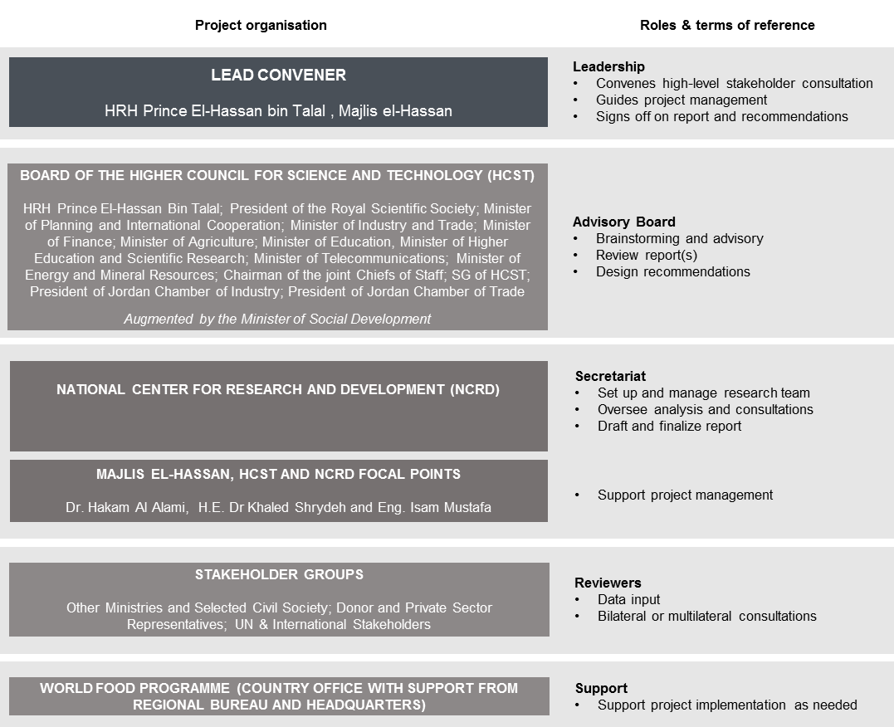
Methodology
Research will rely on quantitative and qualitative research methods, as well as stakeholder consultations. Stakeholder consultations should include:Government line ministries, UN agencies, relevant national and international NGOs, academia, private sector, donors, focus groups with local community representatives such as governorate, municipal and civil society representatives, as well as participants from local Jordanian communities and Syrian refugee communities.
Timeline
The Review will commence following an initial scoping meeting of the augmented Board of the Higher Council for Science and Technology (HCST)in August 2017. The scoping meeting will give further direction and guidance on the scope, structure and timeline of the Review.

